Types
All type names such as classes, struct and Enums should include PascalCase
Public class OnClick() {
}
Public Enum ContactTypes{
}
Public struct Vector2 {
}

Methods

Getters and Setters
All Getter and Setter Methods should be written in camalCase as follows
Public void getName(){
}
Public void setName(){
}

Functions
All methods should be written in pascal case as follows
public void TestFunction() {
}
public bool IsObject() {
}

Fields

Public
Public fields should always be PascalCase

public int Name;
public bool IsPlayed;

Protected
Protected fields should always be camalCase

protected string name;
protected bool isInherted;

Private
Private fields should always be camalCase

private int counter;
private bool isTime;

Project Layout
Scripts should be separated into 3 different folders depending on their types
Main, Controller and Model
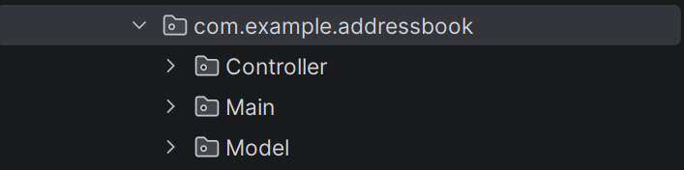
Main should contain the launching applications
Controller should contain the individual component controllers. E.g. Signup Controller, Login Controller
Model should contain base classes that don’t control Ui screens, additionally interfaces, abstract classes should be placed in here as well

Script Layout
The script should be laid out in the following way
- Constants
- Static
- Fields
- Properties
- Methods

Fields Layout
Fields and Methods should have the layout of in the class
- Public
- Protected
- Private

